DARTLER
Phase-by-Phase E-commerce Website & Admin Panel Build Prompts
Production-ready build plan based on the supplied Dartler storefront and admin-panel reference images
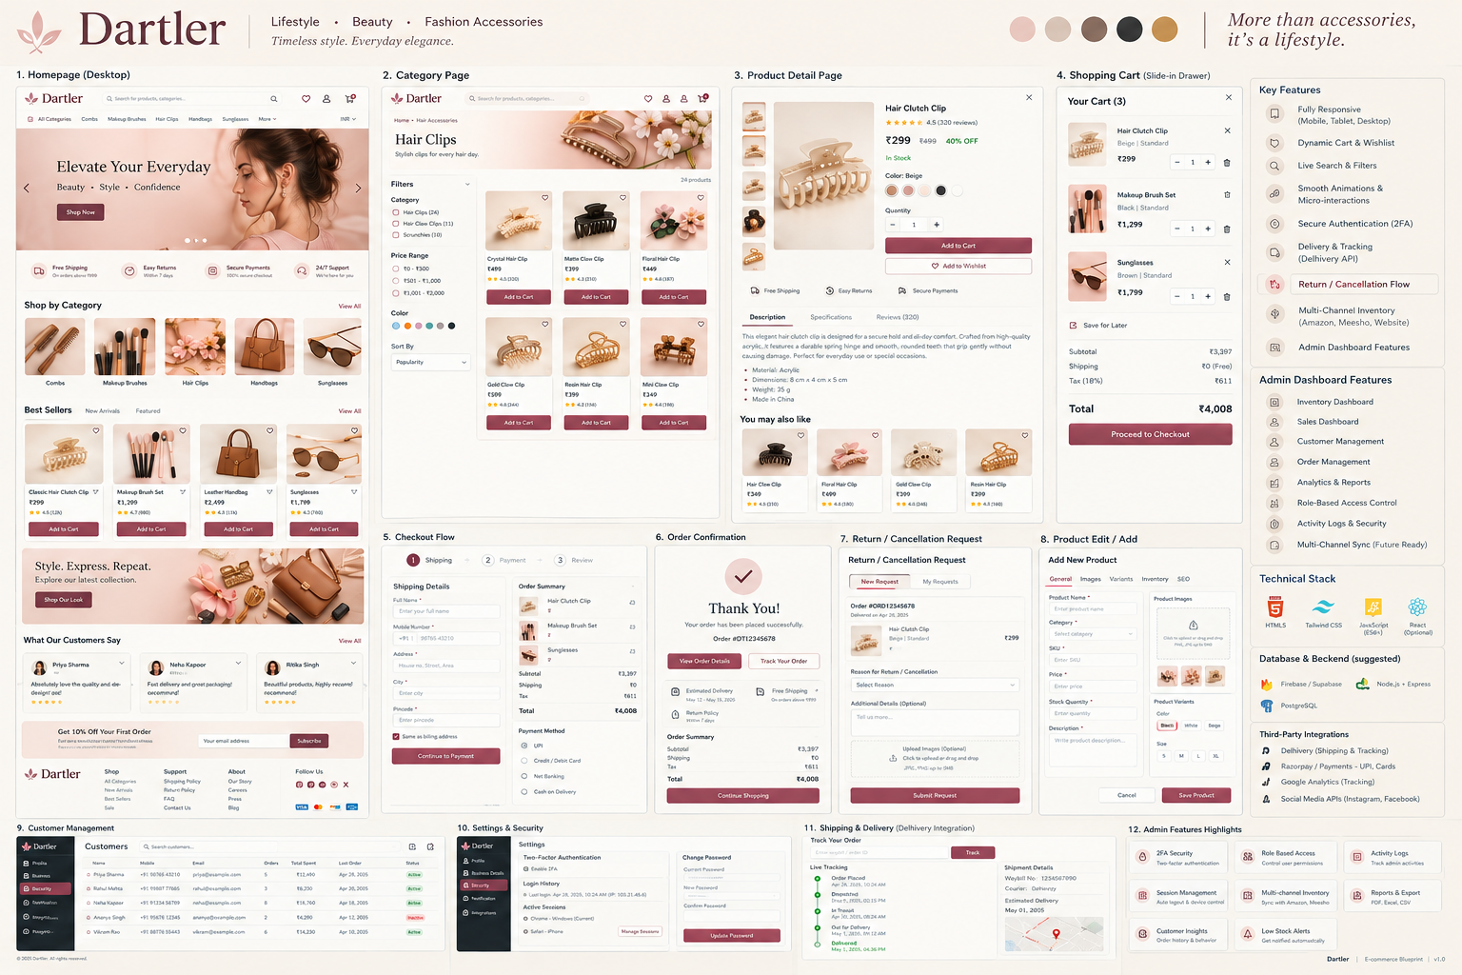
Storefront reference supplied by the user

How to use this document
- Build one phase at a time. Do not ask the coding AI to build the entire application in one prompt.
- After each phase, run the acceptance checklist and fix all errors before starting the next phase.
- Use the same project and codebase throughout. Never recreate the project from scratch between phases.
- Keep the visual language consistent with the reference: warm off-white background, burgundy accents, soft beige/pink product photography, rounded cards, thin borders, elegant serif headings, and clean sans-serif UI text.
- The storefront and admin panel should share the same database and business logic, while remaining separate authenticated areas.
- Use real database-backed CRUD from the first data phase onward; avoid permanent hard-coded product/order data.

Recommended architecture
Layer | Recommended choice | Purpose
Frontend / full-stack app | Next.js + TypeScript | Storefront, admin routes, API/server actions
UI | Tailwind CSS + shadcn/ui | Responsive components and consistent styling
Database | PostgreSQL via Supabase | Products, variants, customers, orders, inventory, returns
Auth | Supabase Auth / secure session auth | Customer accounts + protected admin roles
Images | Supabase Storage or equivalent | Product images and admin uploads
Payments | Razorpay | UPI, cards, net banking; payment verification on server
Shipping | Delhivery API | Shipment creation, AWB, tracking, delivery updates
Notifications | WhatsApp + email provider | Order confirmation, shipping, delivery, return updates
Deployment | Vercel + managed PostgreSQL | Production deployment and environment variables

Core information architecture
- Storefront: Home → Category → Product Details → Cart → Checkout → Payment → Order Confirmation → Track Order → Return/Cancellation.
- Customer account: Profile → Addresses → Orders → Order Details → Wishlist.
- Admin: Dashboard → Products → Orders → Customers → Inventory → Analytics → Reports → Roles & Permissions → Settings & Security → Shipping.
- Important data relationships: Product → Variants → Inventory; Customer → Addresses → Orders; Order → Items → Payment → Shipment → Tracking Events; Order → Return/Cancellation Request.
- All money values should be stored as integer paise in the database or handled with a consistent decimal strategy; never trust client-side totals.

Reference: Admin Panel
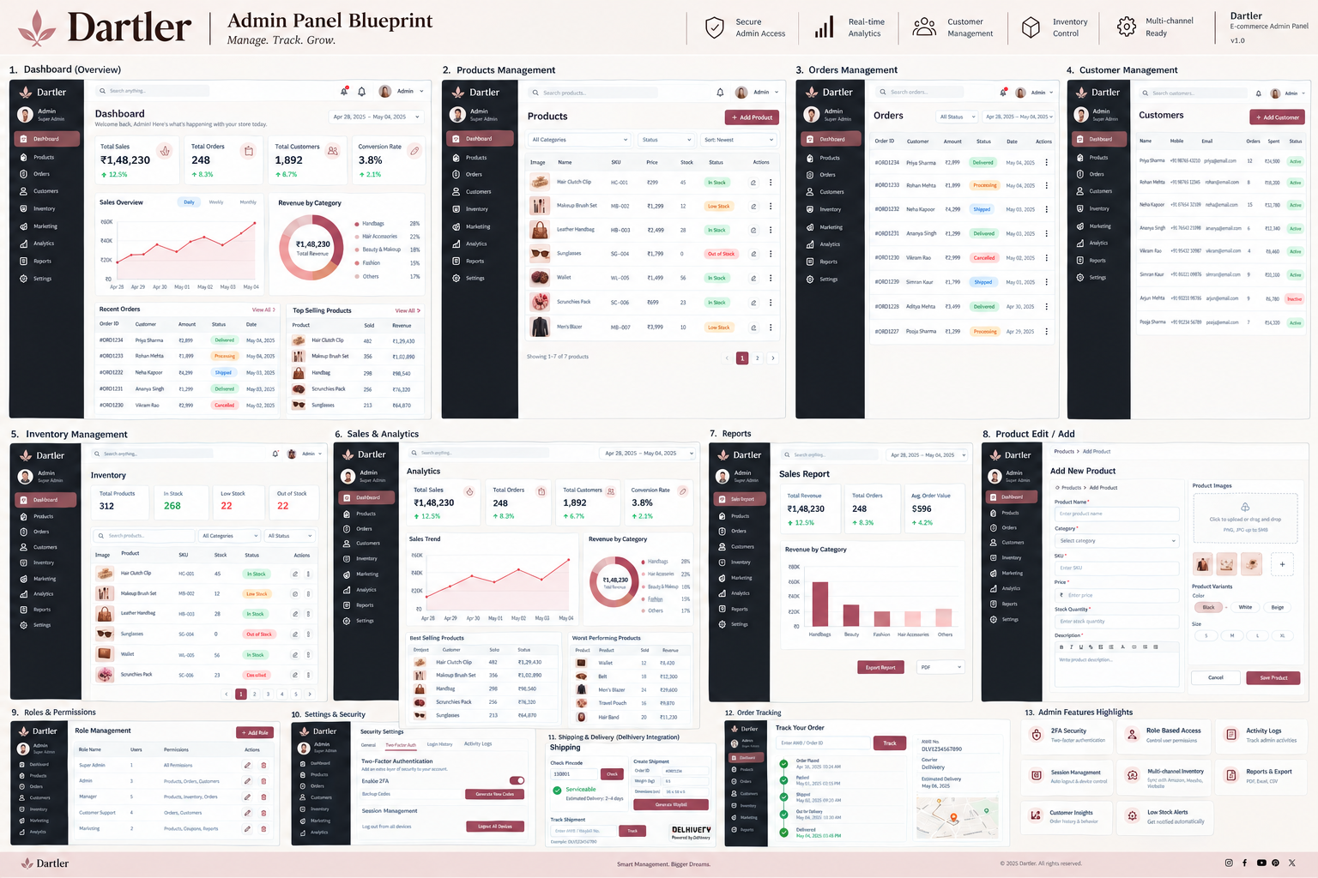
Admin-panel reference supplied by the user

Phase 0 — Project Foundation & Design System
Objective: Create the application skeleton, design tokens, routing structure, reusable components, environment configuration, and reference-driven visual system.

Copy-paste prompt
You are building the Dartler e-commerce platform. Start with ONLY the project foundation; do not build the complete store yet.
Reference:
- Use the supplied Dartler storefront reference image as the visual direction.
- Use the supplied Dartler admin-panel reference image as the admin UI direction.
Create a production-ready Next.js + TypeScript application using Tailwind CSS and a reusable component system. Establish:
1. / for storefront
2. /category/[slug]
3. /product/[slug]
4. /cart
5. /checkout
6. /order/[id]
7. /track-order
8. /account/*
9. /admin/*
10. /admin/login
Create a clean folder structure separating storefront, admin, shared UI, database/server logic, validation, and utilities.
Create a Dartler design system:
- warm ivory/off-white page background
- burgundy/wine primary accent
- beige, taupe, charcoal, muted gold supporting tones
- elegant serif display typography paired with modern sans-serif UI typography
- thin borders, subtle shadows, soft rounded corners
- generous whitespace
- responsive desktop/tablet/mobile layouts
- accessible focus states and keyboard navigation
Create reusable components for Header, Footer, Buttons, Inputs, Selects, ProductCard, Price, Badge, Modal, Drawer, Tabs, Breadcrumbs, EmptyState, LoadingState, Toast, Pagination and DataTable.
Do not hard-code the full product catalog. Use typed placeholder data only where necessary to prove components work.
Add linting, formatting, error handling, loading states and a README explaining how to run the project.
At the end, report:
- files created/changed
- commands to run
- routes created
- unresolved TODOs
- confirmation that the app builds successfully.

Acceptance checklist
- Project starts locally without errors.
- All major routes resolve to placeholder pages.
- Responsive shell exists at mobile, tablet and desktop widths.
- Storefront and admin visual systems are clearly distinguishable but branded consistently.
- No secrets are committed.

Phase 1 — Storefront Shell & Homepage
Objective: Build the customer-facing shell and reproduce the reference homepage composition before connecting real commerce logic.

Copy-paste prompt
Continue from the existing Dartler codebase. Build ONLY the storefront shell and homepage.
Match the supplied Dartler homepage reference closely in hierarchy and spacing, but do not copy any copyrighted assets. Use Dartler's own branding and the product images available in the project.
Homepage sections:
1. Announcement/support strip if useful.
2. Main header with Dartler logo/wordmark, search, wishlist, account and cart.
3. Category navigation: All Categories, Combs, Makeup Brushes, Hair Clips, Handbags, Sunglasses, and More.
4. Large hero banner with lifestyle image, headline, short subheading and Shop Now CTA.
5. Trust row: Free Shipping, Easy Returns, Secure Payments, 24/7 Support.
6. Shop by Category cards.
7. Best Sellers product carousel/grid.
8. Promotional lifestyle banner.
9. Customer reviews/testimonials.
10. Newsletter signup.
11. Footer with categories, support, about, social links and legal links.
Implement:
- responsive navigation
- mobile menu
- sticky/compact header behavior
- search UI
- cart/wishlist counters
- accessible carousel controls
- skeleton loading states
- image aspect-ratio protection
- SEO metadata
- semantic HTML
Keep data mocked in a single typed source for now. Do not create payment, checkout or database logic yet.
Finish by testing the homepage on mobile, tablet and desktop.

Acceptance checklist
- Homepage visually follows the supplied reference hierarchy.
- Header, hero, category cards, product cards, review area and footer are responsive.
- Buttons and navigation work.
- No layout shift from product images.

Phase 2 — Category, Search & Product Listing
Objective: Build the product discovery experience with filters, sorting, search, pagination and reusable product cards.

Copy-paste prompt
Continue from the existing Dartler codebase. Build the category and product-listing experience.
Create /category/[slug] and a reusable listing component.
Requirements:
- category title, description and banner
- breadcrumb
- product count
- responsive filter drawer on mobile
- desktop filter sidebar
- category filter
- price range
- color filter
- availability/in-stock filter
- sorting: Popularity, Newest, Price Low to High, Price High to Low
- search input with debounced interaction
- pagination or load-more
- product cards with image, title, price, rating, wishlist, stock badge and Add to Cart
- hover image behavior where appropriate
- empty and no-results states
- preserve filters in URL query parameters so pages are shareable
Use typed mock products for this phase. Structure the code so replacing the mock repository with PostgreSQL/Supabase later requires minimal UI changes.
Do not implement payment or admin CRUD yet.

Acceptance checklist
- Category pages work for multiple slugs.
- Filters and sorting update visible products.
- Search and query parameters remain in sync.
- Mobile filter drawer works.
- Product cards are reusable across homepage and category pages.

Phase 3 — Product Details Page
Objective: Build a polished PDP matching the supplied reference and prepare it for real inventory, variants and reviews.

Copy-paste prompt
Continue the Dartler project. Build /product/[slug] only.
Match the supplied Product Detail Page reference:
- image thumbnail gallery
- large primary product image
- product name
- rating and review count
- price and optional compare-at price
- stock status
- color/variant selectors
- quantity selector
- Add to Cart
- Buy Now
- Add to Wishlist
- shipping/returns/payment trust information
- tabbed Description / Specifications / Reviews
- related products / You may also like
- mobile-friendly image gallery
Implement:
- URL-based product loading interface
- selected variant state
- quantity validation
- out-of-stock behavior
- accessible buttons and tabs
- image zoom/lightbox if it fits the design
- structured SEO metadata including product title and description
- Product JSON-LD structure prepared for real data
Keep the repository/mock data layer isolated so Phase 5 can replace it with the database.
Do not implement actual payment yet.

Acceptance checklist
- Gallery, variant selection and quantity controls work.
- Cannot add more than available mock stock.
- Out-of-stock products cannot be purchased.
- Related products are displayed.
- Mobile PDP remains usable without horizontal scrolling.

Phase 4 — Cart Drawer & Cart Page
Objective: Implement a real cart state with the slide-in drawer shown in the reference and a full cart page.

Copy-paste prompt
Continue the Dartler project. Implement the shopping cart.
Reference behavior:
- cart opens as a right-side slide-in drawer
- cart shows item image, name, variant, price, quantity controls and remove action
- subtotal, shipping, tax and total are clearly separated
- Save for Later can be shown as a UI action if implemented
- Proceed to Checkout CTA
- empty cart state
Create a shared cart store/context that can later persist to the database for signed-in users.
Requirements:
- add item
- remove item
- update quantity
- merge identical variants
- calculate subtotal
- calculate shipping placeholder
- calculate tax placeholder
- calculate grand total
- optimistic but safe UI updates
- persist guest cart in browser storage
- restore cart on refresh
- protect against invalid quantities
- never trust client totals when an order is created
Create /cart as the full-page cart and keep the drawer reusable throughout the site.

Acceptance checklist
- Cart drawer matches reference behavior.
- Refresh does not lose guest cart.
- Quantity and totals update correctly.
- Empty-cart state is polished.

Phase 5 — Database, Authentication & Product CRUD
Objective: Replace mock commerce data with a real PostgreSQL database and secure authentication.

Copy-paste prompt
Continue from the existing Dartler project. This phase introduces the real backend. Do not redesign the UI.
Use PostgreSQL through Supabase (or the already-selected PostgreSQL provider). Create migrations/schema for:
- profiles
- addresses
- categories
- products
- product_images
- product_variants
- inventory
- wishlists
- wishlist_items
- reviews
- coupons
- orders
- order_items
- payments
- shipments
- tracking_events
- return_requests
- cancellation_requests
- admin_roles
- admin_permissions
- audit_logs
Important:
- use UUID primary keys
- add created_at/updated_at
- use indexes for slugs, SKU, order number, email and common filters
- enforce relational integrity
- keep prices and stock server-controlled
- validate all input with a schema validator
- use row-level security where appropriate
- never expose service-role secrets to the browser
Authentication:
- customer sign-up/login/logout
- session persistence
- password reset
- protected account routes
- protected admin routes
- role-based admin authorization
Create a server-side repository/service layer so UI components do not directly contain database queries.
Then replace the mock product repository with real database reads.

Acceptance checklist
- Database migrations run cleanly.
- Products/categories can be read from PostgreSQL.
- Admin routes are protected.
- Customer and admin authorization are separate.
- Secrets are server-side only.

Phase 6 — Admin Dashboard & Product Management
Objective: Build the admin panel shown in the second reference image and make product management fully functional.

Copy-paste prompt
Continue the Dartler codebase. Build the admin dashboard and Products module based on the supplied admin reference image.
Admin layout:
- dark left sidebar
- Dartler branding
- Dashboard
- Products
- Orders
- Customers
- Inventory
- Marketing
- Analytics
- Reports
- Settings
- top search
- notification area
- admin profile menu
Dashboard:
- Total Sales
- Total Orders
- Total Customers
- Conversion Rate
- sales trend chart
- revenue by category
- recent orders
- top-selling products
Products:
- searchable data table
- category/status/sort filters
- SKU
- price
- stock
- status
- edit action
- delete/archive action
- Add Product button
- pagination
Product Add/Edit:
- General: name, category, SKU, price, stock quantity, description
- Images: upload, reorder, remove, set primary
- Variants: color, size/other attributes, SKU and stock
- Inventory
- SEO: meta title, meta description, slug
- validation and unsaved-change warning
Implement real CRUD against the database created in Phase 5.
Add image upload to storage.
Add server-side validation and authorization.
Never allow an admin client to bypass permission checks.

Acceptance checklist
- Admin dashboard loads real aggregate data.
- Product create/read/update/archive/delete works.
- Image upload works.
- Variants and stock are editable.
- Unauthorized users cannot access admin APIs.

Phase 7 — Checkout, Razorpay Payment & Order Creation
Objective: Build the production checkout flow and secure payment verification.

Copy-paste prompt
Continue the Dartler project. Build the checkout flow shown in the reference.
Checkout steps:
1. Shipping
2. Payment
3. Review
Shipping form:
- full name
- mobile number
- address
- apartment/area
- city
- state
- pincode
- save address
- billing same as shipping
Order summary:
- items
- quantities
- subtotal
- shipping
- tax
- total
Payment:
- integrate Razorpay
- support the payment methods enabled by the merchant account
- create Razorpay order on the server
- open payment checkout from the client
- verify payment signature on the server
- make order creation idempotent
- do not mark an order paid based only on browser success
- handle payment failure, cancellation and retry
- reserve/decrement inventory safely
- prevent duplicate orders from refresh/double clicks
After successful payment:
- create order
- create order items snapshotting product name, SKU, variant and price
- store payment identifiers/status
- show order confirmation page
- send confirmation notification through the configured provider
Use environment variables for all credentials. Never hard-code API keys.

Acceptance checklist
- Successful payment creates exactly one order.
- Failed/cancelled payment does not create a falsely paid order.
- Server verifies payment.
- Inventory cannot become negative.
- Order confirmation contains order number and summary.

Phase 8 — Orders, Customers, Inventory & Admin Operations
Objective: Build the operational admin modules needed to run the store every day.

Copy-paste prompt
Continue the Dartler project. Build these admin modules using real database data.
Orders:
- order list
- search by order ID/customer
- status filters
- date range
- order detail page
- customer/address
- items
- payment status
- shipment status
- internal notes
- status update with audit log
Customers:
- customer list
- search
- order count
- total spend
- last order
- account status
- customer detail
- order history
Inventory:
- total products
- in stock
- low stock
- out of stock
- searchable inventory table
- stock adjustment
- adjustment reason
- inventory history
- low-stock threshold
- prevent negative stock
Reports:
- sales report
- order report
- product report
- inventory report
- export CSV
Analytics:
- total sales
- total orders
- total customers
- conversion rate where data is available
- sales trend
- revenue by category
- best/worst performing products
Keep all aggregates server-side for accuracy and performance.

Acceptance checklist
- Admin can operate orders without editing the database manually.
- Inventory adjustments are auditable.
- Reports export valid CSV.
- Customer data is protected from unauthorized access.

Phase 9 — Delhivery Shipping & Tracking Integration
Objective: Connect the order lifecycle to Delhivery shipment creation and customer tracking.

Copy-paste prompt
Continue the Dartler project. Integrate Delhivery shipping using the official API credentials configured through environment variables.
Create a server-side shipping service abstraction so the app can later support another courier without rewriting the order system.
Required workflow:
1. Paid/confirmed order becomes eligible for shipment.
2. Admin opens the order.
3. Admin can create shipment.
4. Server sends required shipment/order details to Delhivery.
5. Store shipment ID/AWB and courier response.
6. Show shipment status in admin.
7. Customer can track the order.
8. Process tracking updates/webhooks/polling according to the supported Delhivery integration.
9. Map courier statuses to Dartler statuses such as Pending, Confirmed, Shipped, Out for Delivery, Delivered, Failed/Exception, Cancelled.
10. Record tracking events with timestamps.
Create:
- Admin shipping panel
- Create Shipment action
- AWB display
- tracking timeline
- customer Track Order page
- shipment detail card
- error/retry handling
- webhook endpoint if supported
- audit logging
Do not expose the Delhivery API token in the browser. Do not hard-code credentials.

Acceptance checklist
- Shipment creation is server-side.
- AWB/shipment identifiers are stored against the correct order.
- Customer tracking page shows a timeline.
- Shipping API failures are visible and retryable.

Phase 10 — Returns, Cancellations, Refunds & Notifications
Objective: Implement the complete post-purchase workflow highlighted in the storefront reference.

Copy-paste prompt
Continue the Dartler project. Build Return / Cancellation / Refund workflows.
Customer:
- request cancellation when the order status allows it
- request return when eligible
- select reason
- optional additional details
- optional image upload
- see My Requests
- see request status
- receive notifications
Admin:
- Return/Cancellation request list
- request detail
- order and customer context
- approve/reject
- reason
- internal notes
- refund status
- update request status
- audit log
Rules:
- define configurable return window
- define which order statuses allow cancellation/return
- prevent duplicate requests
- validate that the request belongs to the authenticated customer
- never expose another customer's order
- integrate refund processing with the payment provider where supported
- keep payment/refund state separate from order state
Notifications:
- order confirmation
- payment success/failure
- shipment created
- out for delivery
- delivered
- return/cancellation requested
- return/cancellation approved/rejected
- refund initiated/completed
Use templates with Dartler branding.

Acceptance checklist
- Customer can see only their own orders and requests.
- Admin can approve/reject with audit history.
- Refund state is traceable.
- Notifications do not leak sensitive information.

Phase 11 — Security, Roles, Settings & Audit Logs
Objective: Make the platform safer for production and implement the security/settings screens in the reference.

Copy-paste prompt
Continue the Dartler project. Harden security and complete Settings & Security.
Admin roles:
- Super Admin
- Admin
- Manager
- Customer Support
- Marketing
Create permission-based access rather than checking only UI visibility.
Settings:
- Two-factor authentication
- session management
- logout all devices
- password change
- login history
- activity/audit logs
- store profile
- shipping settings
- tax settings
- return window
- low-stock threshold
- notification preferences
Security:
- server-side authorization on every protected mutation
- input validation
- rate limiting on sensitive endpoints
- secure cookies/session handling
- CSRF protection where applicable
- secure file upload validation
- image MIME/type and size checks
- prevent path traversal
- prevent SQL injection by using parameterized/ORM queries
- prevent XSS by escaping/sanitizing user-generated content
- redact secrets from logs
- audit important admin actions
- create friendly 401/403/404/500 pages
Add a security checklist to README and document every required production environment variable.

Acceptance checklist
- Role permissions are enforced server-side.
- Admin actions appear in audit logs.
- 2FA/session settings are represented in the UI.
- Sensitive credentials are never logged.

Phase 12 — Polish, SEO, Performance, Testing & Production Launch
Objective: Turn the completed application into a production-ready ecommerce site.

Copy-paste prompt
This is the final hardening phase for Dartler. Do not add major new features. Audit and improve the existing application.
Visual QA:
- compare every major storefront screen against the supplied reference images
- fix spacing, typography, borders, card proportions and responsive behavior
- verify mobile/tablet/desktop
- ensure images crop correctly
- ensure admin tables work on smaller screens
SEO:
- unique metadata for homepage/category/product pages
- canonical URLs
- Open Graph metadata
- sitemap.xml
- robots.txt
- Product/Organization/Breadcrumb structured data where appropriate
- clean slugs
- no accidental noindex on production pages
Performance:
- optimize product images
- lazy-load noncritical images
- avoid unnecessary client components
- cache safe read-heavy queries
- paginate large admin tables
- prevent N+1 queries
- add loading/skeleton states
- monitor Core Web Vitals
Testing:
- unit tests for price/tax/cart/order calculations
- API/service tests
- authentication/authorization tests
- checkout/payment tests with test credentials
- inventory race-condition tests
- return/cancellation tests
- shipping integration tests/mocks
- end-to-end tests for:
browse → product → cart → checkout → payment → order → tracking
- test admin:
login → product CRUD → order management → inventory → report
Production:
- configure environment variables
- database migrations
- storage rules
- domain
- HTTPS
- error monitoring
- backups
- analytics
- email/WhatsApp provider
- Razorpay production credentials
- Delhivery production credentials
Before declaring completion, produce a launch checklist and list every remaining manual merchant configuration.

Acceptance checklist
- Production build succeeds.
- No console errors on core flows.
- All critical forms have validation and error states.
- Payment and shipping secrets are server-side.
- SEO files and metadata are present.
- Critical customer and admin journeys pass end-to-end tests.

Final Master Prompt — Use After All Phases
You are now working on the completed Dartler e-commerce platform. Do not rebuild or replace the architecture. Treat the existing repository as the source of truth.
Your job is to audit the entire application against:
1. The supplied Dartler storefront reference image.
2. The supplied Dartler admin-panel reference image.
3. The phase requirements in the project documentation.
Audit in this order:
- functionality
- database integrity
- authentication/authorization
- payment correctness
- inventory correctness
- shipping/tracking
- return/cancellation/refund workflow
- responsive UI
- accessibility
- SEO
- performance
- security
- error handling
- production configuration
For every issue:
- identify the file/module
- explain the problem briefly
- implement the safest minimal fix
- test the affected flow
- avoid unrelated rewrites
Do not replace working code just for style preferences. Do not hard-code secrets or business-critical data. Do not claim a feature is complete unless it has been tested.
At the end provide:
- completed audit items
- fixes made
- tests executed and results
- remaining risks
- manual production tasks
- recommended next improvements.

Phase completion rule
Important: Do not move to the next phase until the current phase builds successfully and its acceptance checklist passes. If a coding AI starts implementing later phases automatically, stop it and tell it to finish only the current phase.

Suggested build order at a glance
Phase | Module | Main result
0 | Foundation | Project + design system
1 | Homepage | Storefront shell + home
2 | Discovery | Category + search + filters
3 | PDP | Product detail + variants
4 | Cart | Drawer + cart persistence
5 | Backend | Database + auth + product data
6 | Admin | Dashboard + product CRUD
7 | Checkout | Razorpay + order creation
8 | Operations | Orders + customers + inventory + reports
9 | Shipping | Delhivery + tracking
10 | After-sales | Returns + cancellations + refunds
11 | Security | Roles + settings + audit logs
12 | Launch | SEO + performance + testing + production

Dartler • E-commerce Build Blueprint • v1.0

